**Write python programs to understand**

**a) Basic data types, Operators, expressions and Input Output Statements**

**b) Control flow statements: Conditional statements (if, if...else, nested if)**

**c) Looping in Python (while loop, for loop, nested loops)**

**d) Decorators, Iterators and Generators**.

PRINT STATEMENT:

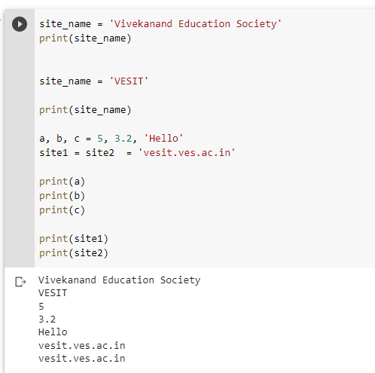

IDENTIFY TYPES:

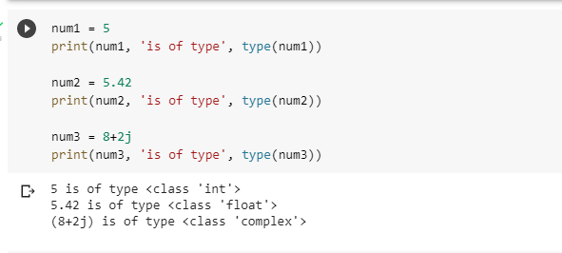

PRINT DATA OF TYPES:

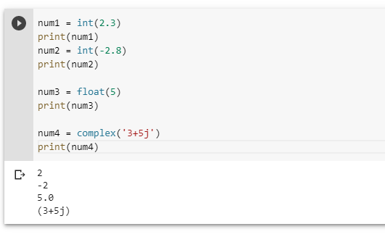

ADDITION OF TWO NUM:

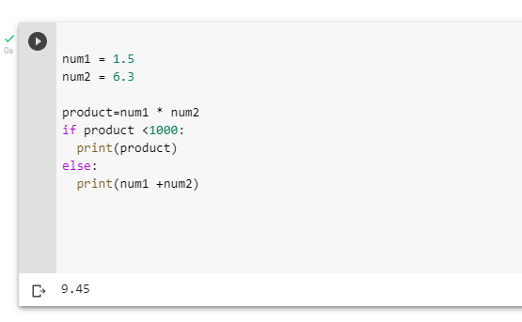

DATA FROM USER:

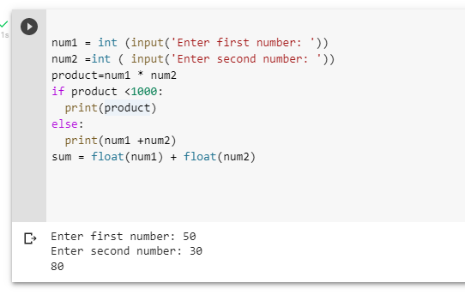

ARITHMETIC OPERATORS:

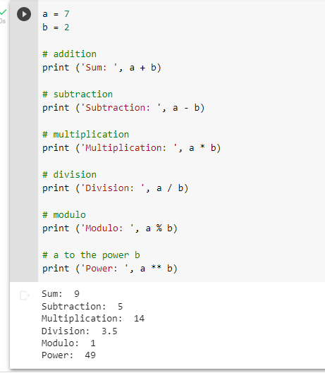

ASSIGNMENT OPERATOR:

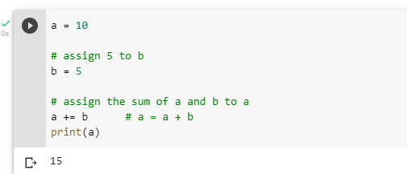

COMPARISON OPERATOR:

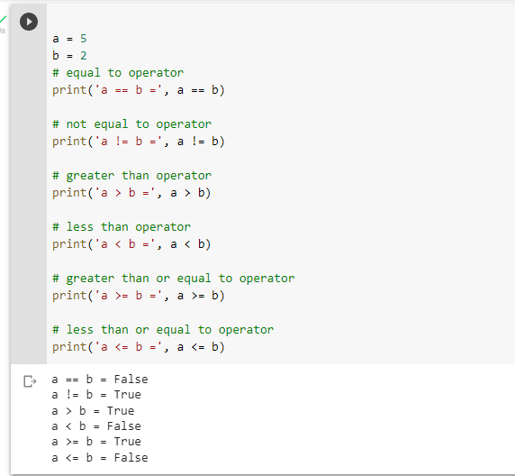

IDENTITY OPERATOR.:

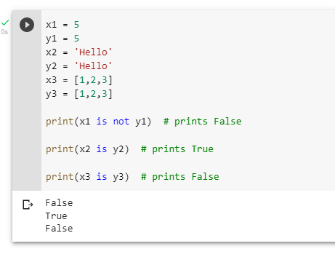

MEMBERSHIP OPERATOR

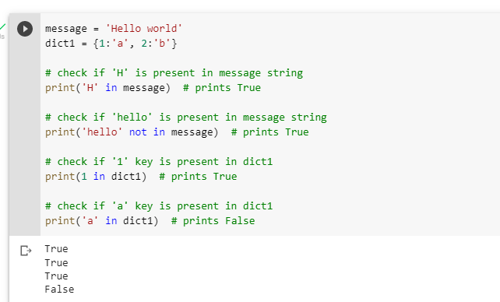

PRINT EVEN NUMBERS:

